# TABLE OF CONTENTS

|  |  |  |
| --- | --- | --- |
| **S.no.** | **Contents** | **Page no.** |
| 1 | INTRODUCTION | 5 |
| 2 | CIRCUIT DIAGRAM AND WORKING PRINCIPLE | 8 |
| 3 | SOFTWARE SIMULATION AND OBSERVATIONS | 9 |
| 4 | .  HARDWARE IMPLEMENTATION | 10 |
| 5 | FUTURE SCOPE | 11 |

# TABLE OF FIGURES

|  |  |  |
| --- | --- | --- |
| **S.no.** | **FIGURE DESCRIPTION** | **Page no.** |
| 1 | Frequency Bands for Various Communication Signals | 6 |
| 2 | Bluetooth Jammer | 8 |
| 3 | Simulation of Jammer Source | 9 |
| 4 | Bluetooth Jammer Equipment | 10 |

**CHAPTER 1**

**INTRODUCTION**

In an increasingly connected world, wireless communication technologies such as mobile phones and Bluetooth devices are ubiquitous. While these technologies offer convenience and efficiency, they also present security challenges, particularly in sensitive areas where the risk of remote-triggered explosive devices, commonly known as remote bombs, is a significant concern. These devices can be triggered using mobile phone signals or Bluetooth frequencies, posing a serious threat to public safety and national security. Mobile and Bluetooth Jammers have thus become critical tools in mitigating such risks by disrupting the communication channels that these threats rely on. This introduction explores the role, functionality, and importance of mobile and Bluetooth Jammers in sensitive areas where remote bombs can be a threat.

**What are Mobile and Bluetooth Jammers?**

Mobile and Bluetooth jammers are devices specifically designed to interfere with and block wireless communications. By emitting signals on the same frequencies as the devices they target, these jammers create a "noise" that disrupts the normal communication channels, rendering the devices inoperative within a certain range.

* **Mobile Jammers:**

**Functionality**: Mobile jammers emit signals that interfere with the frequencies used by mobile phones (e.g., GSM, CDMA, 3G, 4G, LTE). By overpowering the communication signal between a mobile phone and its network tower, these jammers prevent calls, texts, and data transmissions.

**Applications in Sensitive Areas:** In areas at risk of remote bombs, mobile jammers can prevent the detonation of explosives triggered by mobile phone signals. These are often deployed in military zones, government buildings, public events, and other high-security areas.

* **Bluetooth Jammers:**

**Functionality**: Bluetooth jammers operate by emitting interference on the 2.4 GHz ISM band, the frequency range used by Bluetooth devices. This interference blocks the pairing and communication between Bluetooth-enabled devices.

**Applications in Sensitive Areas**: Since some remote bombs can be triggered using Bluetooth signals, jamming these frequencies can prevent such detonations. Bluetooth jammers are essential in scenarios where preventing any form of short-range wireless communication is crucial.

**Technical Aspects and Effectiveness:**

The effectiveness of mobile and Bluetooth jammers in sensitive areas hinges on several key factors:

**Power Output:** The strength of the jamming signal, measured in watts, determines the range within which the jammer can block communications. Higher power output means a larger jamming area.

**Frequency Coverage:** Effective jammers must cover the specific frequencies used by potential remote detonation devices. Mobile jammers typically cover multiple bands (e.g., from 800 MHz to 2600 MHz), while Bluetooth jammers target the 2.4 GHz band.

**Range:** The operational range of a jammer varies from a few meters to several kilometers, depending on its design and intended application. In sensitive areas, a broader range may be required to ensure complete coverage and safety.

**Frequency Bands for Various Communication Signals:**

|  |  |
| --- | --- |
| **Signal Type** | **Frequency Bands** |
| GSM | GSM 850: 824 – 849 MHz (uplink) / 869 – 894 MHz (downlink) |
| GSM 900: 880 – 915 MHz (uplink) / 925 – 960 MHz (downlink) |
| GSM 1800: 1710 – 1785 MHz (uplink) / 1805 – 1880 MHz (downlink) |
| GSM 1900: 1850 – 1910 MHz (uplink) / 1930 – 1990 MHz (downlink) |
| CDMA | CDMA 800: 824 – 849 MHz (uplink) / 869 – 894 MHz (downlink) |
| CDMA 1900: 1850 – 1915 MHz (uplink) / 1930 – 1995 MHz (downlink) |
| 3G (UMTS) | UMTS 850: 824 – 849 MHz (uplink) / 869 – 894 MHz (downlink) |
| UMTS 900: 880 – 915 MHz (uplink) / 925 – 960 MHz (downlink) |
| UMTS 1700/2100 (AWS): 1710 – 1755 MHz (uplink) / 2110 – 2155 MHz (downlink) |
| UMTS 1900: 1850 – 1910 MHz (uplink) / 1930 – 1990 MHz (downlink) |
| UMTS 2100: 1920 – 1980 MHz (uplink) / 2110 – 2170 MHz (downlink) |
| 4G LTE | Band 1 (2100): 1920 – 1980 MHz (uplink) / 2110 – 2170 MHz (downlink) |
| Band 2 (1900): 1850 – 1910 MHz (uplink) / 1930 – 1990 MHz (downlink) |
| Band 3 (1800): 1710 – 1785 MHz (uplink) / 1805 – 1880 MHz (downlink) |
| Band 4 (AWS 1700/2100): 1710 – 1755 MHz (uplink) / 2110 – 2155 MHz (downlink) |
| Band 5 (850): 824 – 849 MHz (uplink) / 869 – 894 MHz (downlink) |
| Band 7 (2600): 2500 – 2570 MHz (uplink) / 2620 – 2690 MHz (downlink) |
| Band 8 (900): 880 – 915 MHz (uplink) / 925 – 960 MHz (downlink) |
| Band 20 (800 DD): 832 – 862 MHz (uplink) / 791 – 821 MHz (downlink) |
| Band 28 (700 APT): 703 – 748 MHz (uplink) / 758 – 803 MHz (downlink) |
| 5G (NR) | Sub-6 GHz bands (FR1): 450 MHz to 6 GHz |
| n1: 1920 – 1980 MHz (uplink) / 2110 – 2170 MHz (downlink) |
| n3: 1710 – 1785 MHz (uplink) / 1805 – 1880 MHz (downlink) |
| n78: 3300 – 3800 MHz |
| mmWave bands (FR2): 24.25 GHz to 52.6 GHz |
| n258: 24.25 – 27.5 GHz |
| n260: 37 – 40 GHz |
| n261: 27.5 – 28.35 GHz |
| Bluetooth | 2.4 GHz ISM band: 2.400 GHz to 2.4835 GHz |
| Wi-Fi | 2.4 GHz Band: 2.400 GHz to 2.4835 GHz |
| 5 GHz Band: 5.150 GHz to 5.250 GHz, 5.250 GHz to 5.350 GHz, 5.470 GHz to 5.725 GHz, 5.725 GHz to 5.850 GHz |
| 6 GHz Band: 5.925 GHz to 7.125 GHz |
| RFID | Low Frequency (LF): 30 kHz to 300 kHz |
| High Frequency (HF): 13.56 MHz |
| Ultra-High Frequency (UHF): 860 MHz to 960 MHz |
| Microwave: 2.45 GHz and 5.8 GHz |
| GPS | L1: 1575.42 MHz |
| L2: 1227.60 MHz |
| L5: 1176.45 MHz |
| Zigbee | 2.4 GHz: 2.400 GHz to 2.484 GHz |
| 915 MHz: 902 MHz to 928 MHz |
| 868 MHz: 868 MHz to 868.6 MHz |
| LoRa | 433 MHz band (Asia) |
| 868 MHz band (Europe) |
| 915 MHz band (North America) |
| NFC | 13.56 MHz |

**Fig1: Frequency Bands for Various Communication Signals**

## CHAPTER 2

## CIRCUIT DIAGRAM AND WORKING PRINCIPLE

**Circuit diagram :**

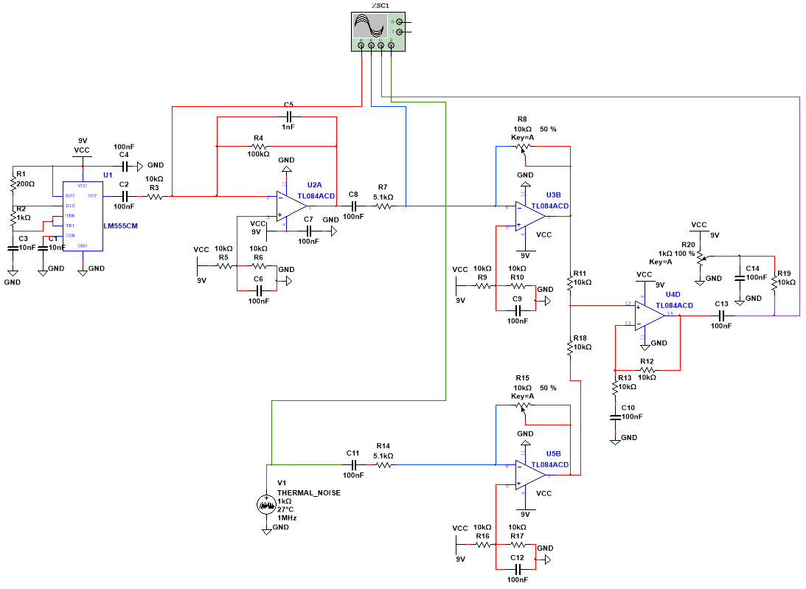

**Fig2: Bluetooth Jammer**

**Working principle:**

A Bluetooth jammer disrupts Bluetooth communications by emitting signals within the 2.4 GHz ISM band, the same frequency range used by Bluetooth devices. Bluetooth operates from 2.400 GHz to 2.4835 GHz and uses a frequency hopping technique to minimize interference. A jammer generates radio frequency (RF) signals that either cover the entire Bluetooth frequency range (broadband jamming) or target specific frequencies (narrowband jamming). These interfering signals mix with genuine Bluetooth signals, causing signal degradation, connection failures, and communication interruptions. Bluetooth jammers can be handheld, stationary, or software-based. Handheld jammers are portable and battery-operated, suitable for disrupting Bluetooth in a specific area, while stationary jammers are larger and cover broader areas with higher power output. Software-based jammers are less common but can be deployed on existing hardware. The jammer's effectiveness depends on its power output and the environment, with obstructions like walls reducing the range. It is crucial to consider the legal and ethical implications, as jammers can disrupt not only targeted devices but also other critical communications, and unauthorized use can lead to severe legal consequences.

## CHAPTER 3

## SOFTWARE SIMULATION OBSERVATIONS

**Observation:**

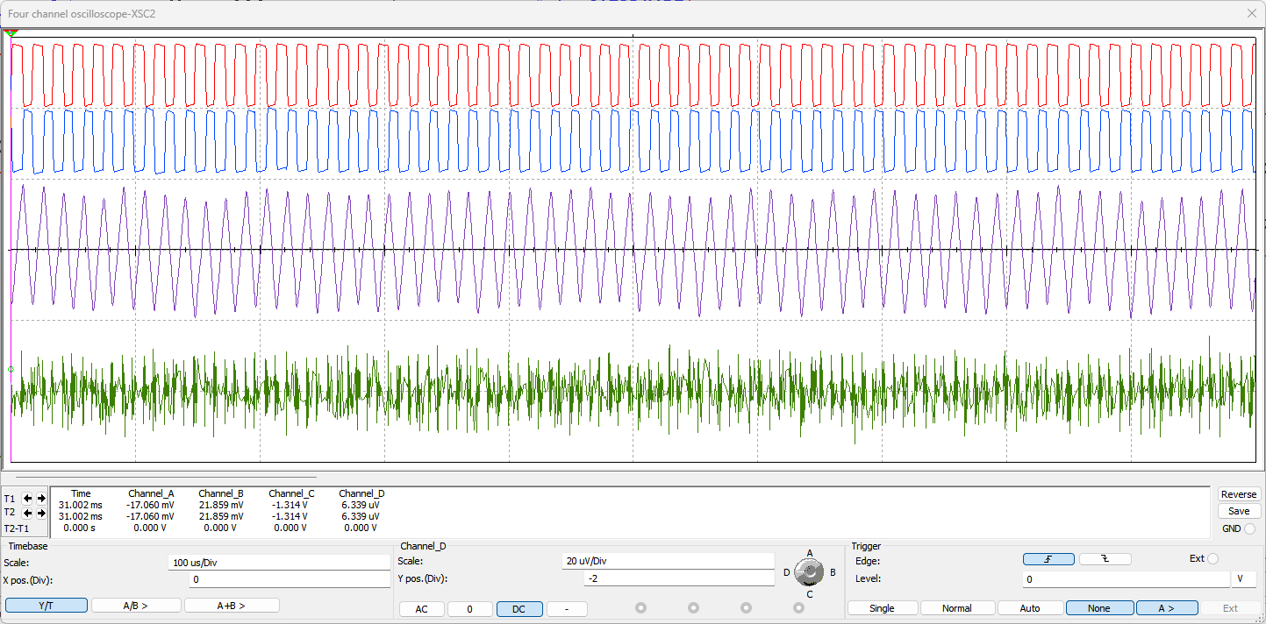

**Fig3: Simulation of Jammer Source**

**Conclusion:**

In a simulated environment testing Bluetooth jammer effectiveness, the jammer proved capable of significantly disrupting Bluetooth communication operating within the 2.4 GHz ISM band. Initially, two Bluetooth devices, Device A and Device B, established a stable connection for data transmission. When the jammer was activated in broadband mode, emitting signals across the entire 2.4 GHz band, both devices experienced severe interference. This resulted in erratic data transmission, frequent connection drops, and compromised communication reliability. Narrowband jamming, targeting specific frequencies within the Bluetooth hopping sequence, also disrupted communication albeit to a lesser extent, causing intermittent data loss and slower transmission rates. The effectiveness of the jammer varied with distance, with closer proximity amplifying its impact and distances beyond 10 meters reducing its disruptive effect. Additionally, physical barriers such as walls attenuated the jammer's interference, emphasizing the importance of line-of-sight for optimal disruption. These observations underscore the potential of Bluetooth jammers in controlled settings but highlight the ethical and regulatory considerations surrounding their use due to their broad and disruptive impact on wireless communications.

## CHAPTER 4

**HARDWARE IMPLEMENTATION**

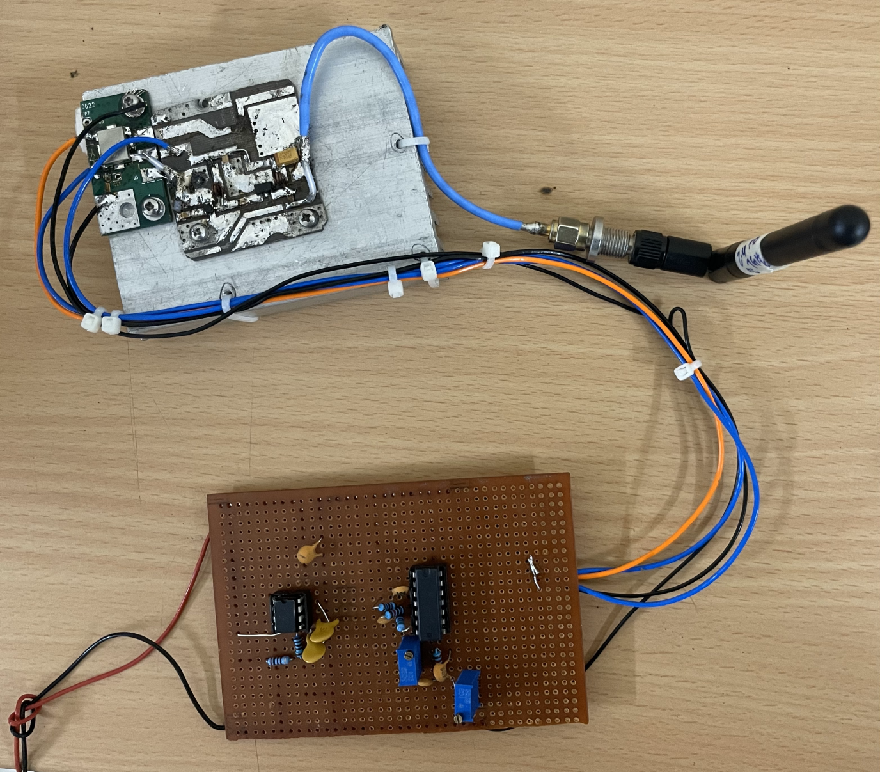

**Fig4: Bluetooth Jammer Equipment**

“Apply 5V DC Supply to activate the Jammer”.

**Conclusion :**

The hardware equipment of a Bluetooth jammer powered by a 5V DC supply demonstrates effective disruption of Bluetooth communications within the 2.4 GHz ISM band. This setup ensures reliable operation with sufficient power efficiency, making it suitable for various applications where controlled interference is necessary. However, the ethical implications and regulatory considerations surrounding the deployment of such equipment must be carefully evaluated to mitigate potential risks and ensure responsible usage in accordance with legal frameworks governing wireless communication devices.

## CHAPTER 5

**FUTURE SCOPE**

Looking into the future, the scope of jammers, including Bluetooth jammers, presents several potential developments and applications. As technology evolves and communication protocols advance, the role of jammers may adapt in the following ways:

1. **Adaptation to New Frequencies:** With the proliferation of 5G networks and beyond, jammers may need to adapt to disrupt frequencies beyond the traditional 2.4 GHz and 5 GHz bands. This could involve developing jammers capable of targeting higher frequencies used in 5G mmWave bands or other emerging wireless technologies.

## **Advanced Signal Processing:** Future jammers may integrate advanced signal processing techniques to enhance their effectiveness. This could include adaptive jamming algorithms that dynamically adjust jamming frequencies and power levels to overcome frequency hopping and other anti-jamming techniques employed by modern communication systems.

## **Software-Defined Jammers:** Jammers leveraging software-defined radio (SDR) technology could become more prevalent. These jammers offer flexibility in terms of programmability, allowing operators to adapt jamming strategies to specific scenarios and frequencies with greater precision.

## **Integration with AI and Machine Learning:** Incorporating artificial intelligence (AI) and machine learning (ML) algorithms could enable jammers to autonomously detect and target communication signals more effectively. This adaptive capability could enhance jamming performance while minimizing unintended disruption to non-targeted communications.

## **Miniaturization and Mobility:** Advancements in miniaturization may lead to smaller, more portable jamming devices. This could facilitate their deployment in various environments, including mobile applications where rapid deployment and flexibility are crucial.

## **Regulatory and Ethical Considerations:** As jammers evolve, there will be a continued need to address regulatory and ethical concerns. Striking a balance between legitimate uses, such as preventing unauthorized communication in secure environments, and potential misuse or interference with critical communications, will remain paramount.

## **Cybersecurity Applications:** Jammers could find applications in cybersecurity, such as defending against wireless attacks or securing sensitive networks from unauthorized Bluetooth or Wi-Fi access points.